USA Energy Consmption
(COMP3125 Individual Project)

Daniel Tapia

Abstract—This project analyzes historical U.S. primary energy consumption from 1975 to 2024 across five major sectors: electric power, transportation, industrial, residential, and commercial. Time-series trend analysis is used to examine long-term changes. Sectoral growth rates are then evaluated to identify the fastest-growing sector. Finally, linear regression is applied to determine whether electric power consumption can be predicted using transportation energy consumption. Total U.S. primary energy consumption exhibits a long-term increase across the observed period, followed by a phase of relative stabilization after 2008. The electric power sector exhibited the fastest growth rate, and a strong linear relationship was found between transportation and electric power consumption (R² ≈ 0.79), indicating significant predictive capability. These findings highlight the structural shift toward electrification in U.S. energy use.
Keywords— Energy Consumption, Primary Energy, Regression Analysis, Sector

Introduction (Heading 1)
Primary energy consumption in the United States has undergone significant changes over the past several decades, driven by technological progress, economic growth, policy shifts, and evolving patterns of demand across major sectors of society. The electric power and transportation sectors have grown to represent the largest consumers of energy, reflecting increased electrification and continued dependence on motor fuels. Understanding how these sectors contribute to overall national energy use is valuable for policymakers, utility planners, and analysts working toward sustainable energy systems. This study investigates three primary research questions: (1) how total U.S. primary energy consumption has changed over the past 50 years, (2) which energy sector has experienced the fastest growth rate, and (3) whether U.S. electric power consumption can be predicted using historical energy consumption from other sectors.

Datasets

Source of dataset (Heading 2)
The dataset used in this project was obtained from Statista, a well-known statistical aggregation platform that compiles data from verified government, institutional, and industry sources. The specific dataset, “Primary energy consumption in the United States from 1975 to 2024, by sector,” is based on historical energy data originally published by the U.S. Energy Information Administration (EIA).
The dataset contains EIA-reported estimates of annual primary energy consumption measured in quadrillion British thermal units. The data was generated using national energy accounting procedures conducted by the EIA, which include the aggregation of consumption from electricity generation, transportation, industrial processes, residential use, and commercial activity. Since Statista directly reproduces these values without altering units or restructuring the data, the dataset is considered credible, consistent, and suitable for analytical use.

Character of the datasets
The dataset consists of 21 observations, each representing a five-year interval between 1975 and 2024. Each observation records the U.S. primary energy consumption for five major economic sectors. The dataset is structured in a tabular format with one row per year and one column per sector, along with the year variable. All values are reported in quadrillion Btu (British thermal units). Statista provided clean data; no unit conversions needed.
Data preprocessing included removing metatdata rows from the original Excel file, renaming columns for consistency, and verifying no missing values remained. A new variable, total energy consumption, was created by summing the five sectoral values for each year.

Methodology
This project employs three primary analytical methods: time-series trend analysis, sectoral growth rate comparison, and linear regression modeling. Time-series analysis is used to evaluate long-term changes in U.S. total primary energy consumption. Sectoral growth rates are computed to identify which energy sector experienced the fastest relative increase over time. Finally, simple linear regression is applied to determine whether U.S. electric power consumption can be predicted using transportation energy consumption as a predictor. Model assumptions were evaluated using correlation analysis and residual diagnostics.

Method A
Time-series trend analysis was applied to examine how total U.S. primary energy consumption was changed from 1975 to 2024. Total energy consumption was calculated as the sum of electric power, transportation, industrial, residential, and commercial energy usage at each time point. A line plot was then used to visualize the long-term trend and identify periods of growth, stabilization, or decline. A five-year moving average was subsequently computed and overlaid to smooth short-term fluctuations and provide a generalized representation of the underlying trend.

Method B

Sectoral growth rates were computed using percent change between the first and last observations for each sector. The percent growth rate for each sector was calculated using the formula:

$$\frac{(\text{Final Value} \text{-} \text{Initial Value})}{\text{Initial Value}} ×\text{100}$$ | (1)

These growth rates were then ranked to determine which sector experienced the fastest relative growth over the study period.

Method C
A simple linear regression was developed to predict U.S. electric power consumption using transportation as the predictor variable. Transportation energy was selected after correlation analysis revealed a strong linear relationship with electric power consumption (r ≈ 0.89), while industrial, residential, and commercial sectors exhibited weak or non-linear correlations. Model performance was evaluated using the coefficient of determination (R²). A residual diagnostic plot was also generated to assess the adequacy of the linear regression assumptions. Finally, a regression plot comparing actual and predicted electric power values was generated using transportation energy consumption as the predictor to visually evaluate model performance.

Results
This section presents the primary findings of the study, organized according to the three research questions introduced earlier. Specifically, the results address (1) how total U.S. primary energy consumption has changed over the past 50 years, (2) which energy sector has experienced the fastest growth rate, and (3) whether U.S. electric power consumption can be predicted using historical energy consumption from other sectors. Each subsection below presents the corresponding results and interpretation.

Result A
Total U.S. primary energy consumption increased substantially from 1975 through the mid-2000s. After approximately 2008, total energy consumption began to stabilize, with a noticeable decline occurring around 2020. A partial recovery is observed in the most recent years of the dataset. Overall, the long-term trend reflects significant growth followed by structural stabilization.
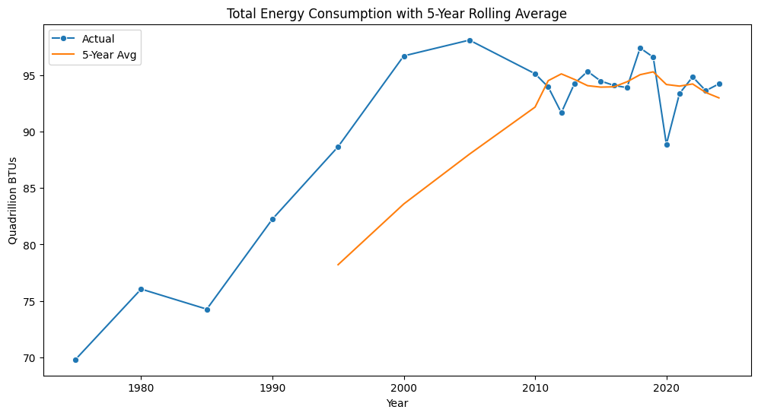

Results B
Percent growth rate analysis revealed that the electric power sector experienced the fastest relative increase in energy consumption over the study period, with an approximate growth rate of 80.6%. Transportation ranked second in growth, while industrial and commercial sectors exhibited modest changes. Residential energy consumption showed a net decline over the same period. These results indicate a strong long-term shift toward increased electric power consumption relative to other major sectors.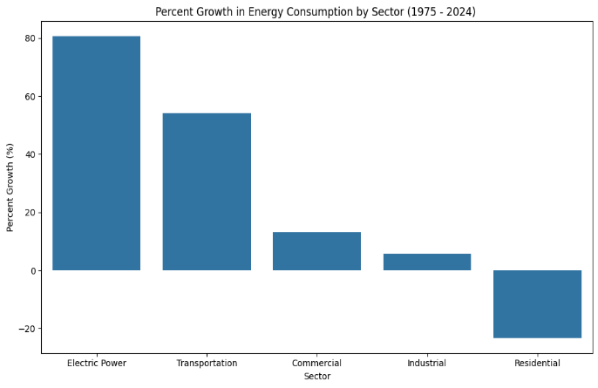

Results C

Correlation analysis indicated a strong positive linear relationship between transportation and electric power consumption (r ≈ 0.89). A simple linear regression model was therefore constructed using transportation energy as the predictor variable. The fitted regression model produced a strong coefficient of determination (R² ≈ 0.79), indicating that a large proportion of the variability in electric power consumption can be explained by transportation energy usage alone.
Residual analysis showed no clear systematic pattern, supporting the assumption that linear regression model is appropriate for this relationship.
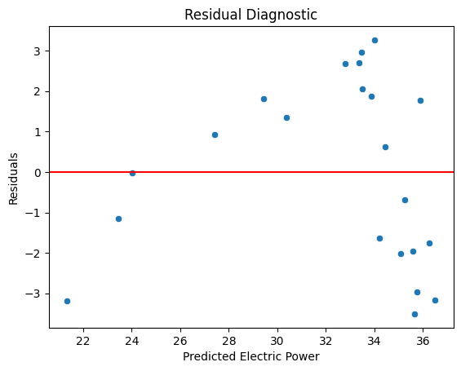
A linear regression plot was constructed to evaluate the predictive accuracy of the model by overlaying the fitted regression line on the observed data points. The results indicate a clear positive linear relationship between transportation energy consumption and electric power consumption. The regression line closely follows the overall upward trend of the observed data, demonstrating that the model captures the general pattern of the relationship effectively. While some clustering of the observed electric power values is present at higher levels of transportation energy consumption, the regression model provides a reasonable line of best fit across the full range of the data, supporting its suitability for prediction.
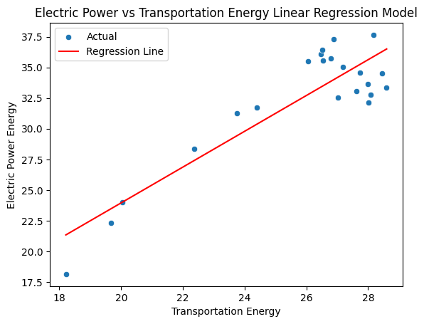

Discussion
While the results demonstrate strong statistical relationships between transportation and electric power consumption, several limitations exist. The dataset consists of five-year intervals rather than annual observations, which reduces temporal resolution. Additionally, the regression model does not account for external drivers such as policy changes, fuel price shocks, or technological shifts such as electric vehicle adoption. Future work could incorporate higher-frequency data, renewable energy penetration, and nonlinear machine learning models to improve predictive accuracy.

Conclusion
This project examined long-term trends in U.S. primary energy consumption, sectoral growth patterns, and the predictive relationship between transportation and electric power consumption. Results show that total U.S. energy consumption increased substantially from 1975 through the early 2000s before stabilizing after 2008. The electric power sector exhibited the fastest growth rate, increasing by approximately 80.6% over the study period. Linear regression results further demonstrated that transportation energy consumption is a strong predictor of electric power demand. These findings highlight the increasing interconnectedness between transportation and electricity systems and emphasize the importance of electrification in future U.S. energy planning.

References
[1] “Primary energy consumption in the United States in selected years from 1975 to 2024, by sector,” Statista, Jun. 2025. https://www.statista.com/statistics/239782/primary-energy-consumption-in-the-united-states-by-sector/
[2] EIA, “U.S. Energy Information Administration (EIA) - Total Energy Monthly Data,” Eia.gov, 2025. https://www.eia.gov/totalenergy/data/monthly/
[3] G. James, D. Witten, T. Hastie, R. Tibshirani, and J. Taylor, An Introduction to Statistical Learning. Springer, 2023. doi: https://doi.org/10.1007/978-3-031-38747-0.

